**LetsUpgrade AWS Assignment 1 Day 3**

**PROJECT 1 : Deploying a web server in Windows instance**

**Windows EC2 Instance Details :**

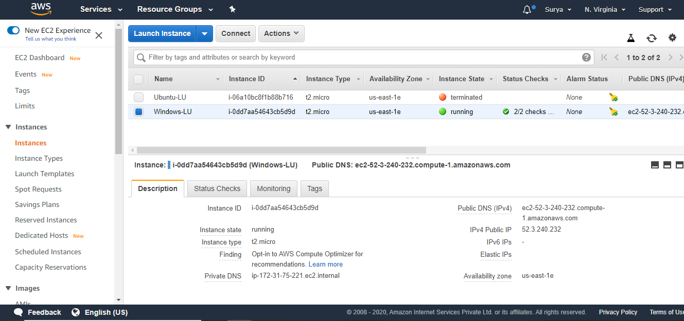

**IIS server in Windows EC2 instance :**

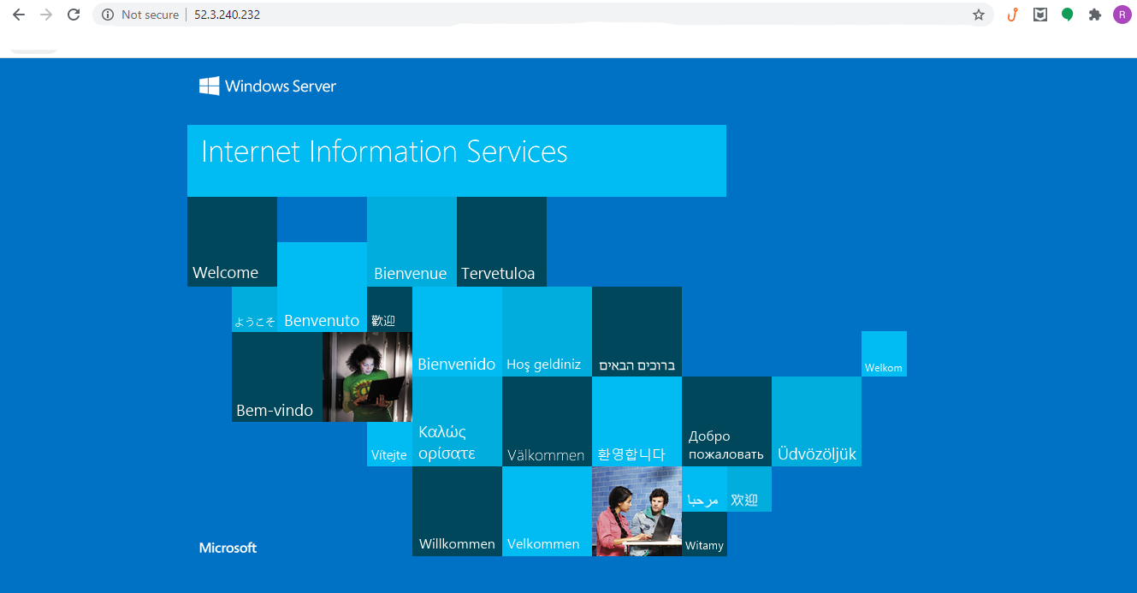

**PROJECT 2 : Deploying a web server in Ubuntu instance**

**Ubuntu EC2 Instance Details :**

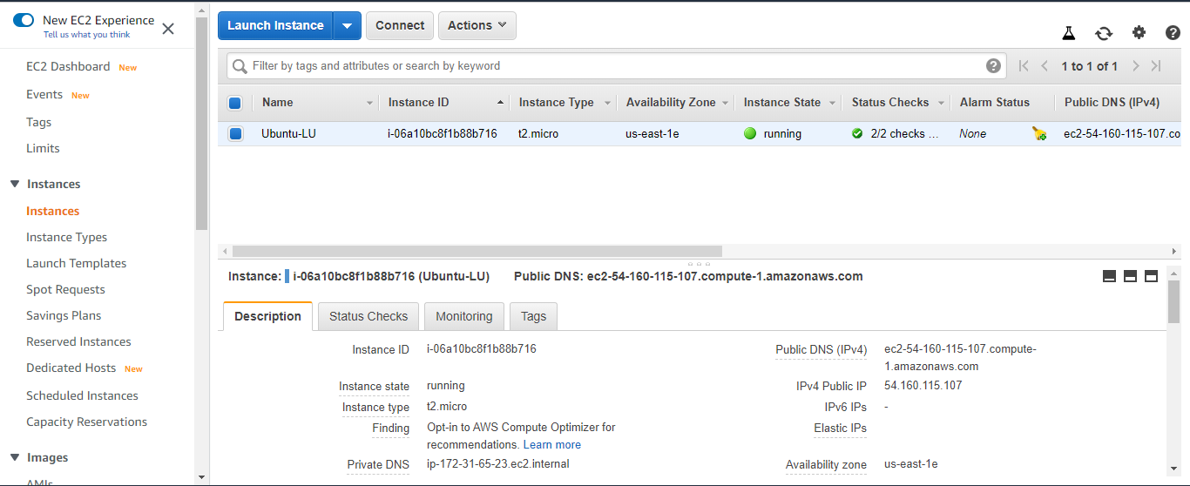

**Nginx web server in Ubuntu EC2 instance :**